Ultrasonic sensor for car project

Circuit Diagram:

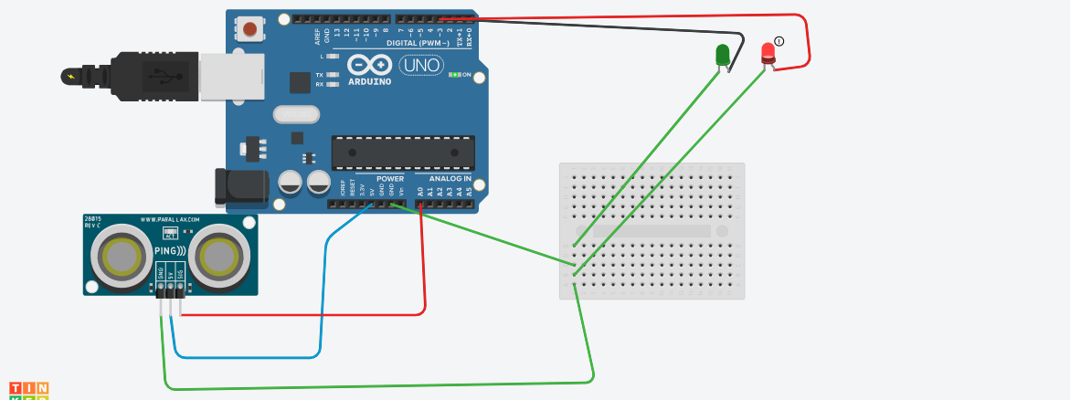

Theory:

Concept Used:

1)In this project ,we have used the ultrasonic distance sensor for the security of the car .if anyone or anything come closer to the car and the sonic waves send by the sensor will detect that by echo reverse waves

2)here , we setup the code as if sensor range is less than 100 than red light will glow for every 10 microseconds and and if it goes back it and greater than 100 it glows red light for every 20 microseconds

3) In this we can also use buzzer for more impact

Learning & Observations:

**Learning:**

1) I have learnt to use Arduino Board and how code works to

Ultrasonic sensor by waves

2) How a circuit is placed on breadboard so that it can work properly.

3) Arduino board has Digital pins and Analog pins.

Digital pin provides Input as well as Output, but Analog pin provides only input.

4) The Arduino board has ~ sign in Digital pin side which is also known as Pulse Width Modulation (PWM)**.**

These pins help’s in getting analog results with digital means.

5) Since the LED can bear a limited supply of voltage so we have used resistance in series with the LED so that the voltage gets divided and LED can use the require amount of voltage.

**Observations:**

1) The Arduino board can provide a supply of 5V to the chaser circuit.

2) here we connected the vcc to the 5v pin in analog port

And grd t grd and signal to A0 pin (analog pin). It is used for the input of the waves to the Arduino and red led positive to digital pin3 and green led positive to digital pin2.andboth negatives to the grd pin in Arduino board.

3) After uploading the code on the Arduino software, when the sensor senses any echo signal then it responds accordingly

Problems and Troubleshooting:

1) The circuit on the bread board is not relevant so the circuit will not work.

I have fixed it by recognizing the circuit properly and again make the circuit on the board.

Precaution:

1) We need to handle the elements of the device with good care.

2) The connections on the Arduino board must coincide with the codes written on the software.

3) During the writing of the codes, the insertion of delay should not be forgotten and that too of the required time interval and not any random value.

4) In the IDE of Arduino the instructions should be given only in void loop section.

Learning and Outcomes:

1)I have learnt to make circuits using breadboard, Arduino board and other equipment.

2)I have learnt the various methods to use the ultrasonic sensor for various purpose like security, counting and safty purpose have learnt to make other type of gadgets related to this concept.

4)I have learnt how we can use the Arduino board for doing various tasks.

5)I have learnt about the elements of Arduino board and its functions.